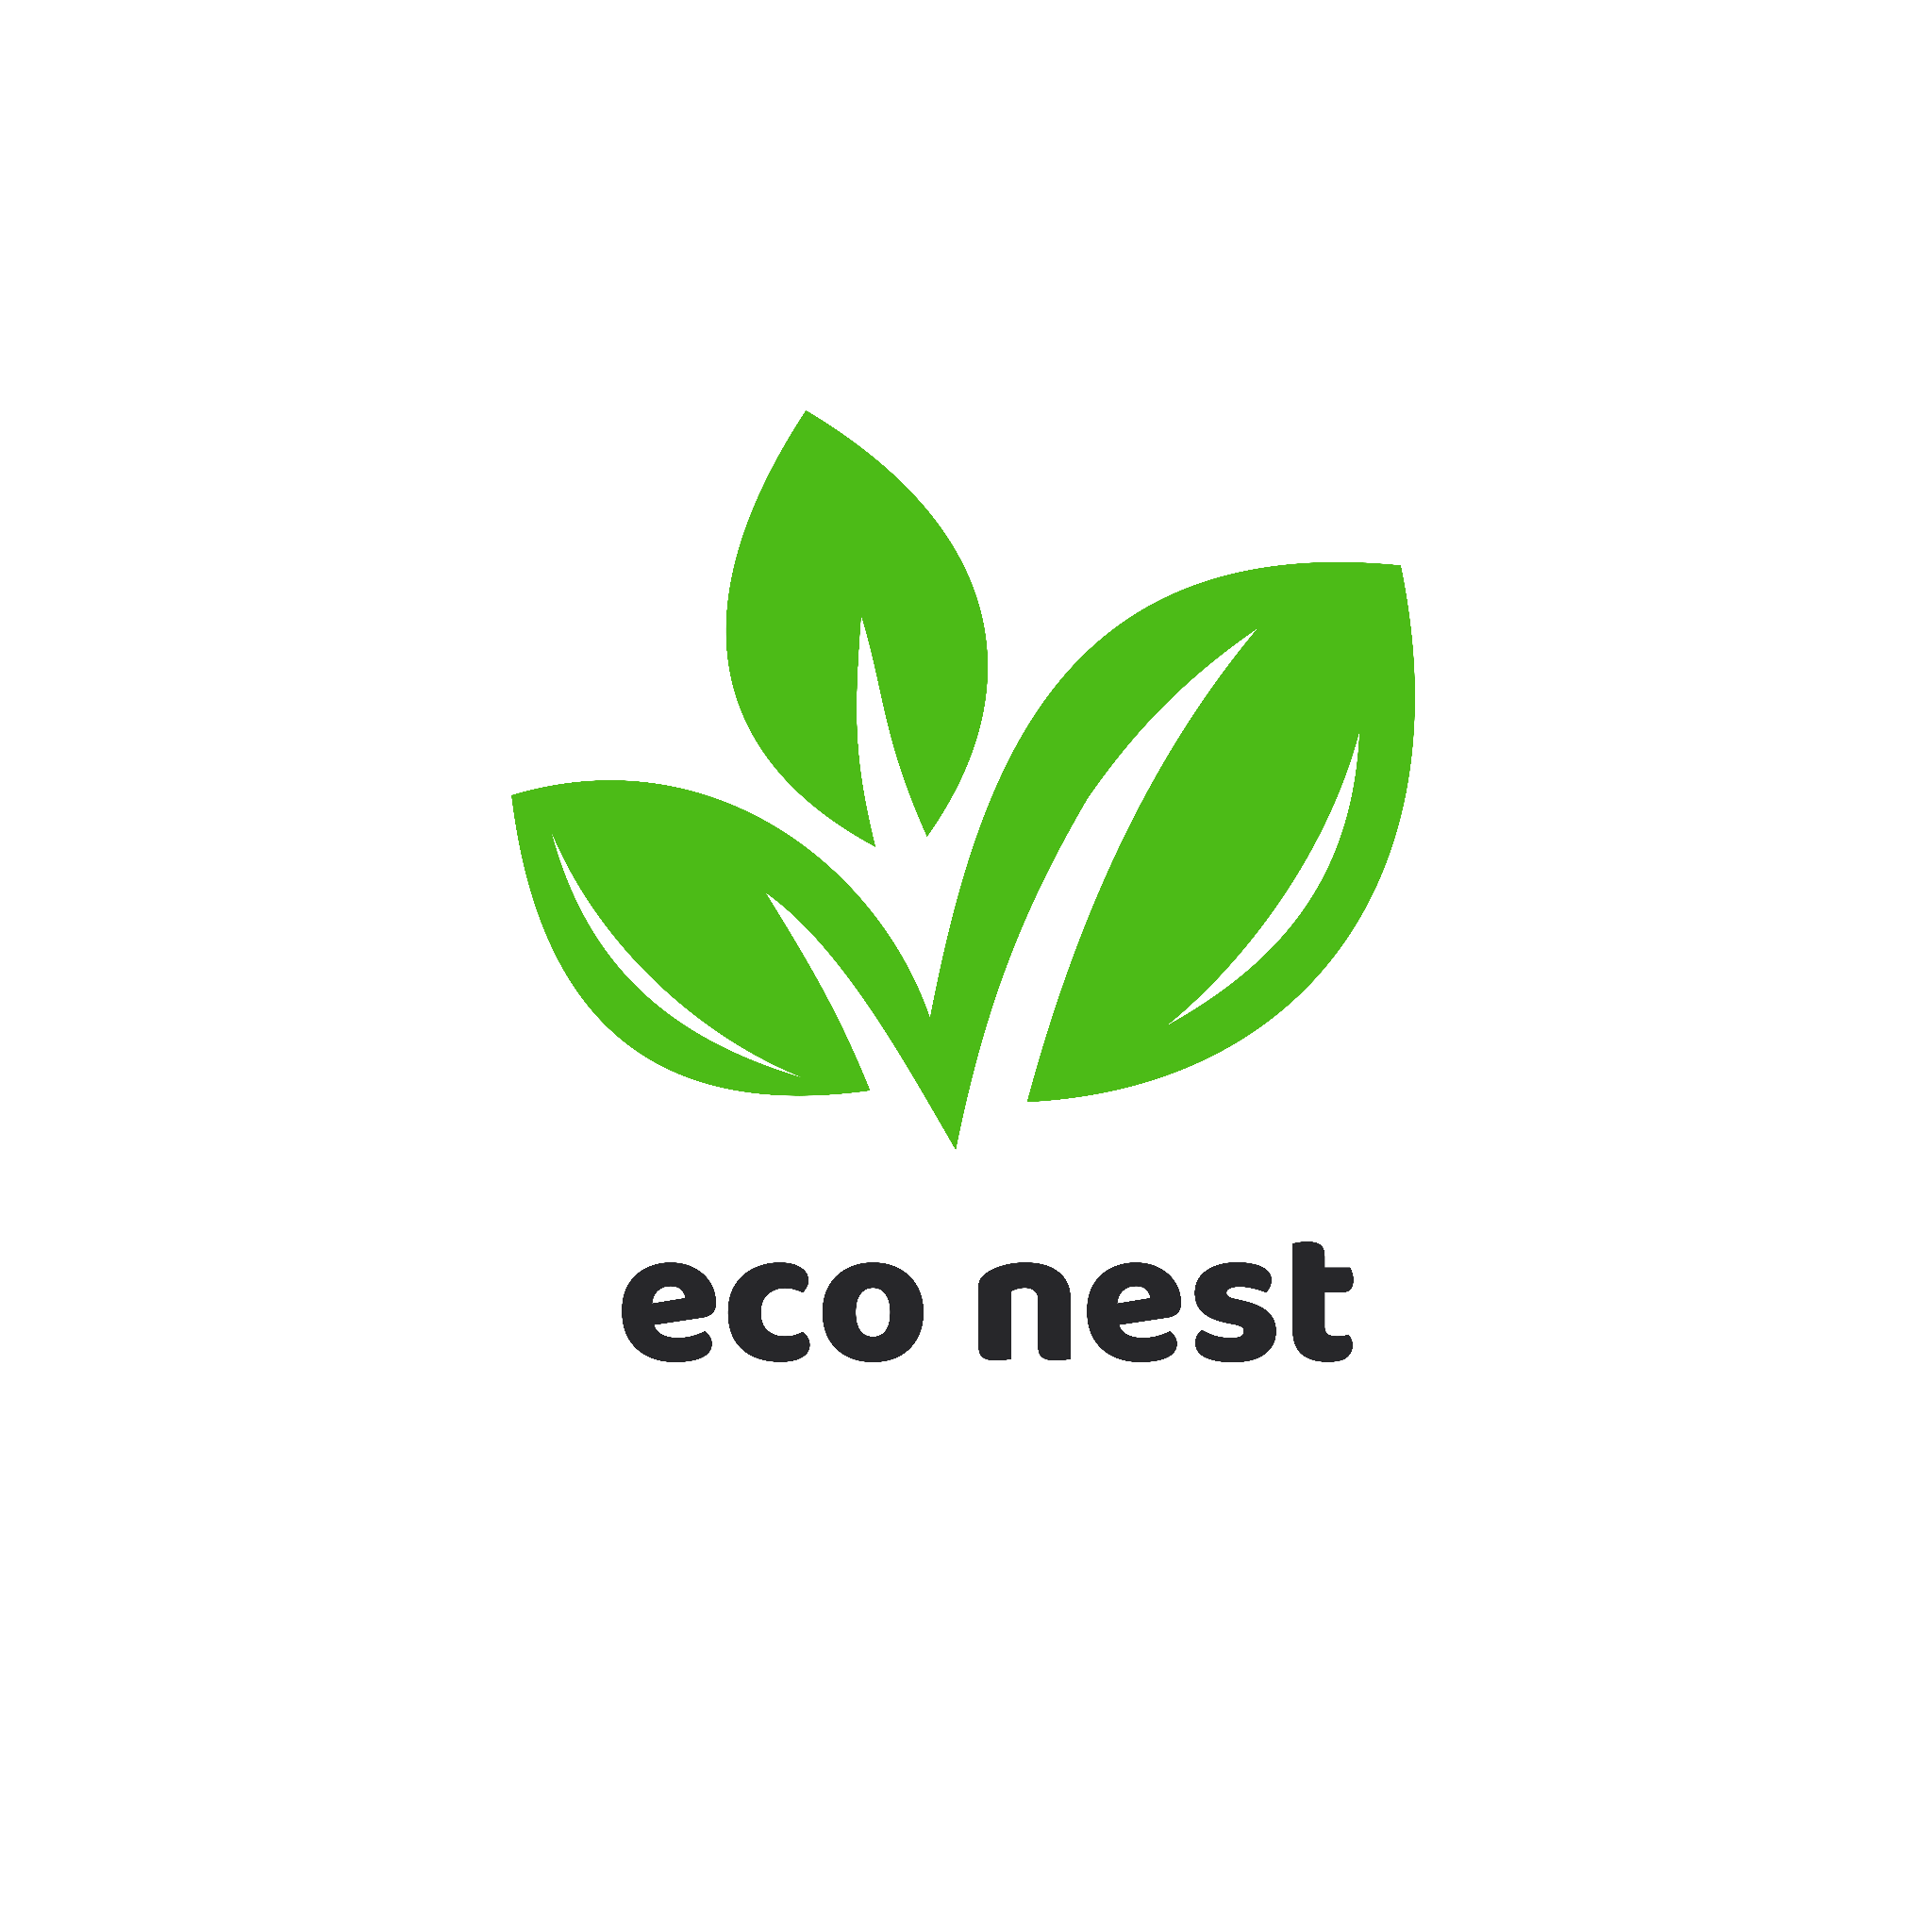

EcoNest Creations

A sustainable home décor brand

**Name :** Jannatul Ferdaus Mahin

**Batch :** 50

**Date :** 14/12/24

# **Table of Content**

**Executive Summary** 3

**Products and Services** 3

**Meet with our samples** 4

**Business Plan** 5

**Sales & Cost Statistics** 5

**Revenue Breakdown** 5

**Market Analysis** 6

**Pricing** 6

**Contact Info** 7

# **Executive Summary**

EcoNest Creations is a sustainable home décor company committed to creating eco-friendly, handcrafted products that blend functionality and style. Established in 2024, our mission is to inspire a sustainable lifestyle through beautiful, earth-conscious designs. By combining traditional craftsmanship with modern aesthetics, EcoNest Creations aims to become a leader in the eco-friendly home décor market.

# **Products and Services**

#### **Products**

1. **Recycled Wooden Furniture:** Tables, chairs, and shelves crafted from reclaimed wood.
2. **Eco-Friendly Decor Items:** Wall hangings, plant holders, and lamps made from sustainable materials.
3. **Biodegradable Kitchenware:** Plates, bowls, and cutlery made from bamboo and coconut husks.

#### **Services**

* **Interior Design Consultation:** Eco-friendly home makeover advice.
* **Custom Décor Orders:** Personalized products crafted to customer specifications.

[Learn more about our products here!](http://ww1.examplelink.com/?terms=create%20a%20domain%20for%20website,register%20a%20url%20address,get%20a%20free%20domain%20for%20website)

# 

**Product Categories**

***Furniture***

***Kitchenware***

***Décor***

# 

# **Meet with our samples**

|  |  |  |
| --- | --- | --- |
|  |  |  |
|  |  |  |

**👉🏻** [**Click here to show more**](http://ww1.examplelink.com/?terms=create%20a%20domain%20for%20website,register%20a%20url%20address,get%20a%20free%20domain%20for%20website)

# **Business Plan**

# **Sales & Cost Statistics**

**Sales and Profit Analysis (From Jan 2023 to Mar 2023)**

|  |  |  |  |
| --- | --- | --- | --- |
| **Month** | **Sales (৳)** | **Costs (৳)** | **Profit (৳)** |
| January | 1,00000 | 60,000 | 40,000 |
| February | 89,000 | 70,000 | 19,000 |
| March | 2,00000 | 90,000 | 1,00000 |

# **Revenue Breakdown**

# **Market Analysis**

EcoNest Creations operates in a rapidly growing market for sustainable home décor. A recent survey indicates that **70%** of consumers prefer eco-friendly products due to environmental concerns. This shift in consumer preferences is driving the market's annual growth rate of **15%**.The global home décor market, currently valued at **$200 billion**, is projected to reach **$300 billion** by 2030. EcoNest aims to capture a **5%** market share by 2026.

# **Pricing**

|  |  |  |
| --- | --- | --- |
| **Product/Services** | **Price (৳)** | **Description** |
| Handmade Bamboo Lamps | 1,200 | Eco-friendly and aesthetic lighting |
| |  | | --- | | Recycled Wall Hangings |  |  | | --- | |  | | 850 | Stylish décor made from recycled materials |
| |  | | --- | | Sustainable Kitchenware Set |  |  | | --- | |  | | 2,500 | Includes plates, bowls, and utensils |
| Custom Home Décor Designs | Starting from 5,000 | Personalized designs for any space |
| Indoor Planters | 1,000 | |  | | --- | |  |  |  | | --- | | Durable, biodegradable plant pots | |

# **Contact Info**

*For inquiries or collaborations, please contact us:*

* **Email:** info@econestcreations.com
* **Phone:** +123-456-7890
* **Website:** www.econestcreations.com